# 



23

BQ

1A0506

23

BQ

1A0508

23

BQ

1A0558

23

BQ

1A0560

**TEAM-12**

**DESIGN**

**THINKING &**

**INNOVATION**

**REPORT**

**DEPARTMENT OF COMPUTER SCIENCE & ENGINEERING (CSE)**

**VASIREDDY VENKATADRI INSTITUTE OF TECHNOLOGY: NAMBUR**

**JAWAHARLAL NEHRU TECHNOLOGICAL UNIVERSITY KAKINADA**



**CERTIFICATE**

This is to certify that the project titled “**STREAMLIFY [DTI]”** is a bonafide record of work done by **A. Harshitha Sai,** **A. Shakeena Rani, D. Naga Srinidhi, D. Manvith Kumar Reddy** under the guidance of **Mr. P. R. Krishna Prasad**, **Associate Professor** in partial fulfillment of the requirement for the award of credits to **Design Thinking & Innovation -** course of Bachelor of Technology in Computer Science & Engineering, JNTUK during the academic year 2024-25.

Mr. P. R. Krishna Prasad Dr. V. Rama Chandran

**Course Instructor Head of the Department**

**ACKNOWLEDGEMENT**

*We express our sincere thanks wherever it is due*

We express our sincere thanks to the **Chairman**, Vasireddy Venkatadri Institute of Technology, Sri **Vasireddy Vidya Sagar** for providing us well equipped infrastructure and environment.

We thank **Dr. Y. Mallikarjuna Reddy**, **Principal**, Vasireddy Venkatadri Institute of Technology, Nambur, for providing us the resources for carrying out the project.

We express our sincere thanks to **Dr. K. Giribabu**, **Dean of Academics** for providing support and stimulating environment for developing the project.

Our sincere thanks to **Dr. V. Rama Chandran**, **Head of the Department**, **Department of CSE**, for his co-operation and guidance which helped us to make our project successful and complete in all aspects.

We also express our sincere thanks and are grateful to our guide **Mr. P. R. Krishna Prasad**, **Associate Professor, Department of CSE**, for motivating us to make our project successful and fully complete. We are grateful for his precious guidance and suggestions.

We also place our floral gratitude to all other teaching staff and lab technicians for their constant support and advice throughout the project.

**NAME OF THE CANDIDATE**

24BQ5A0101 – A. Vamsi Krishna

24BQ5A0102 – A. Anil Kumar

24BQ1A0103 – A. Arjun

**TABLE OF CONTENTS**

1. **Problem Statement 01**
2. **Phases of Design Thinking 01-32**

1 **Empathy *01-11***

* 1. Brainstorming (Explore & Exploit) 02-04
  2. List of Stakeholders/Customers 04-05
  3. Customer Interaction 05-06
  4. Tools and Strategies Used 06-11
     + - User Interviews
       - Observation (Shadowing, Fly-on-the-Wall)
       - Empathy Maps
       - Surveys & Questionnaires
       - Stakeholder Maps
       - Personas

2 **Define *12-20***

* 1. Point-of-View (POV) Statements 12-13
  2. How Might We (HMW) Questions 13
  3. Journey Maps/User Story Mapping 14-16
  4. Problem Trees 17-20

3 **Ideate** *(Choose any one)* ***21-24***

* + - * Brainstorming & Brainwriting
      * SCAMPER
      * Mind Mapping 21
      * Crazy 8s
      * Worst Possible Idea
      * Storyboarding 22-24

4 **Prototype** *(Choose any one)* ***25-28***

* + - * Sketching & Wireframing
      * Paper Prototyping
      * Low-Fidelity Mockups
      * 3D Printing
      * Click-through Prototypes 25-28
      * Wizard of Oz Prototyping

5 **Test** *(Choose any one)* ***29-32***

* + - * Usability Testing 29-32
      * A/B Testing
      * Feedback Surveys
      * Think-Aloud Testing
      * Eye Tracking
      * Heuristic Evaluation

1. **Reflections 33-37**
2. **References 38**

# PROBLEM STATEMENT

"Hilly and mountainous regions pose significant challenges to road safety due to their naturally hazardous terrain, including sharp curves, steep inclines, narrow roads, low visibility, unpredictable weather conditions such as fog, rain, or snow, and frequent occurrences of landslides and falling debris. These environmental factors, combined with limited infrastructure, poor road maintenance, and the absence of real-time monitoring systems, significantly increase the risk of road accidents—particularly for unfamiliar drivers such as tourists or transporters operating under time pressure. In many of these remote regions, conventional safety mechanisms like road signs and guardrails are either inadequate or not visible in adverse conditions, and human monitoring is often impossible due to the inaccessibility and isolation of these areas. To address this critical gap, there is a growing need for a smart sensorbased system that can actively monitor road conditions, environmental factors, and driving patterns in real time, identify potential hazards or high-risk driving behavior, and deliver timely alerts to both drivers and relevant authorities. Such a system would not only enhance driver awareness and decisionmaking but also provide actionable data for road safety management, enabling authorities to implement preventive measures more effectively. Ultimately, this proactive approach to accident prevention through intelligent sensor technology has the potential to significantly reduce the frequency and severity of accidents in hilly regions, saving lives and improving the overall safety of transportation in challenging terrains. Accidents in hilly terrains are a major safety concern due to factors such as sharp bends, steep gradients, low visibility, frequent landslides, and changing weather conditions. Conventional warning systems fail to provide real-time hazard detection and driver assistance. There is a need for a smart sensor system capable of monitoring road conditions, vehicle behavior, and environmental factors in real-time. This system should be able to predict and prevent potential accidents by providing timely warnings to drivers and emergency services. Challenges include robust sensor integration, reliable data processing in harsh environments, low-latency communication, and cost-effective deployment across remote areas

**DESIGN THINKING PHASES**

# 1. EMPATHY

The Empathy Phase is the foundational step in the Design Thinking process, where the primary objective is to develop a deep, human-centered understanding of the people we are designing for. In the context of designing a Smart Sensor System for Accident Prevention in Hilly Regions, this phase involves immersing ourselves in the lives and experiences of those who navigate and manage these challenging terrains every day.

Hilly and mountainous regions often pose unique and unpredictable challenges, including narrow winding roads, poor visibility due to fog or rain, sudden landslides, and limited infrastructure for communication or emergency response. To design an effective and life-saving smart system, it is crucial to step into the shoes of local drivers, tourists, emergency responders, and authorities to understand their pain points, behaviors, emotions, and real needs.

During this phase, we engage in various empathy-building activities such as field observations, interviews, surveys, and real-world immersions to gather insights directly from users. This helps us uncover not only their obvious problems but also the **latent or unspoken needs** that could drive innovative solutions.

By deeply understanding users’ daily struggles, fears, and desires, we ensure that our design is not just technically sound, but also meaningful, relevant, and user-centric. The insights gathered in this phase will shape the problem definition and guide the development of a solution that is both effective and empathetic.

## 1.1 BRAINSTORMING

### 1. Smart Sensing & Detection

* Road-embedded sensors to detect slipperiness (ice, water, mud) and landslides in real time
* Vehicle-mounted LIDAR or ultrasonic sensors to sense approaching blind curves or obstacles ahead
* Edge AI devices on roadside poles to analyze traffic speed, fog density, and real-time vehicle behavior
* Gyroscope/accelerometer sensors in vehicles to detect dangerous tilts or loss of control

### 2. Driver Alerts & Feedback

* Heads-Up Display (HUD) with real-time road condition warnings (fog ahead, slow down, curve approaching)
* Haptic feedback in steering wheel or driver’s seat to warn during sharp turns or over speeding
* Voice assistant integration to give predictive driving advice based on terrain data
* Vibration-based alerts for drowsy or distracted drivers using eye tracking or motion sensing

### 3. Connectivity in Remote Areas

* LoRa (Long Range) mesh networks between sensor units for communication without mobile coverage
* Offline mode AI for in-vehicle systems that continue processing data even without connectivity
* Emergency alert beacon transmitters that work via GPS/satellite in case of detected risk or crash

### 4. Data Collection & Analytics

* Real-time mapping of high-risk **zones** based on environmental and traffic sensor data
* Cloud dashboard for traffic authorities to visualize road condition trends and accident patterns
* Heat maps of frequent braking zones or overspeed areas for preventive infrastructure changes
* Vehicle behavior analytics (frequent gear shifting, braking) to suggest road upgrades

### 5. System Integration & Scalability

* Integration with Google Maps or other GPS system**s** for hazard notifications in route planning
* Modular sensor kits for easy installation on existing roads or vehicles
* Use of solar-powered roadside sensors to make the system energy-efficient
* Low-cost mobile app for driver community reporting hazards (potholes, rockfalls)

### 1.2 LIST OF STAKE HOLDERS

#### Primary Stakeholders (Direct Users & Beneficiaries)

1. Drivers (Local and Tourist)

Benefit from real-time alerts and safety features

o Include car drivers, bikers, taxi drivers, truck operators, etc.

1. Commercial Transport Companies o Logistics and delivery services operating in hilly areas o Responsible for fleet safety and insurance reduction
2. Public Transport Authorities o Bus operators and mountain transit agencies that need to ensure passenger safety
3. Emergency Services (Police, Ambulance, Fire) o Use crash detection data to respond faster and more accurately

#### Secondary Stakeholders (Indirect Users / Enablers)

1. Road and Highway Authorities o State/central government departments responsible for road safety and infrastructure o Could integrate the system into smart road networks
2. Disaster Management Authorities o Especially in landslide or avalanche-prone regions
3. Insurance Companies o May offer incentives for vehicles using proactive safety systems o Interested in accident data analytics
4. Local Government and Municipal Bodies o Can support deployment through local funding and road development plans

#### System Enablers & Development Partners

1. Technology Providers / IoT Companies o Developers of smart sensors, edge devices, connectivity modules
2. Telecommunication & Satellite Service Providers

• For data transmission in areas with poor mobile coverage

11. Automobile Manufacturers

• Potential partners for in-built systems in vehicles (OEM integration)

12. AI & Software Developers

• To build analytics, alert algorithms, and driver behavior monitoring

## 1.3 CUSTOMER INTERACTION

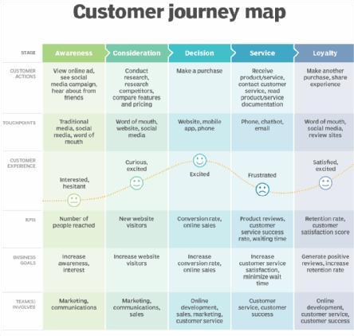

## 1.4 TOOLS AND STRATEGIES

### 1.4.1 USER INTERVIEWS

To gain a deeper understanding of the real-world challenges faced in hilly regions regarding road safety, a series of user interviews were conducted with individuals directly affected by or involved in hill

* Drivers and tourists want real-time warnings and visual/audio alerts.
* Emergency responders need automatic crash detection and GPS location updates.
* Villagers and locals often act as informal safety managers and would welcome technology to reduce risk.
* Authorities need data-driven insights for proactive road management and safety interventions.

transport and emergency services.

### 1.4.2 OBSREVATION METHOD

a. shadowing

During the shadowing observations, it was noted that drivers in hilly regions often rely on instinct and limited visual cues to navigate dangerous areas such as sharp turns, steep slopes, and low-visibility conditions. While driving, many reacted to immediate hazards such as fog or roadblocks only when directly in sight, often too late to prevent accidents. Local residents attempted to mitigate risks with makeshift warning signs, but these were inconsistent and often unnoticed by tourists. b. Fly-on-the-wall it was evident that drivers in hilly regions often engaged in risky behaviors, such as speeding through blind curves or not adjusting their speed for changing weather conditions like rain or fog. Despite the presence of basic road signs, there was a lack of dynamic, real-time alerts for hazards like landslides or slippery patches, leading to reactive rather than proactive driving. Emergency responders also faced delays due to unclear accident locations

### 1.4.3 EMPATHY MAP



**1.4.4**

**SURVEYS & QUESTIONNARIES**

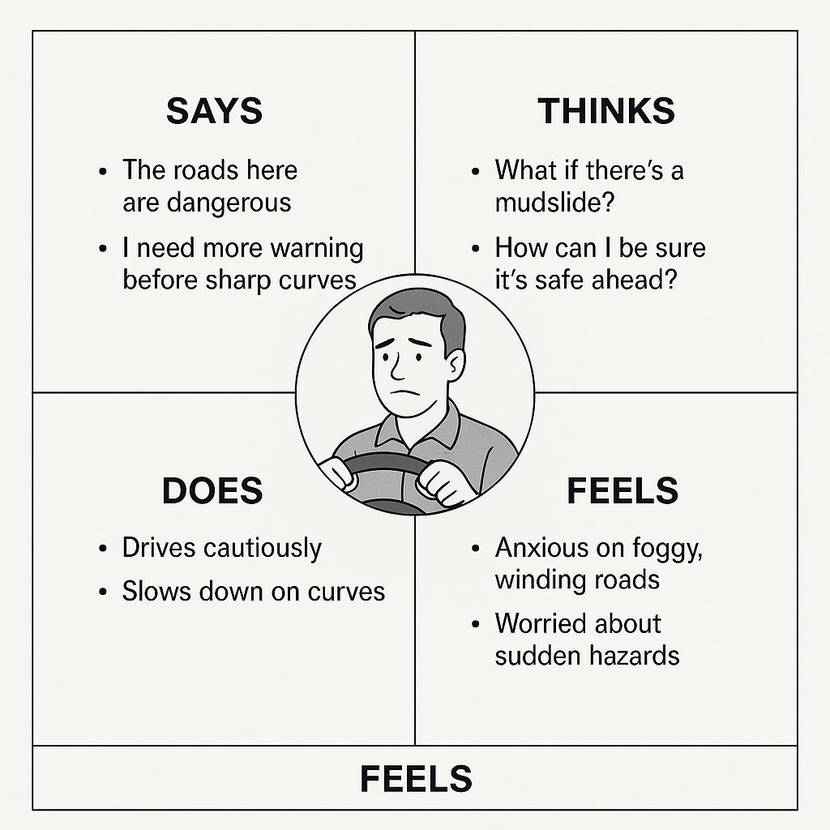

This survey is designed to gather feedback on your experience with road safety in hilly regions and to assess how a **smart sensor system** could help improve accident prevention. Your responses will help design a system that meets the needs of drivers, local residents, and emergency responders.

* 85% of respondents showed strong interest in a system that provides real-time warnings for landslides, sharp turns, and weather-related hazards.
* Over 70% of users have experienced or witnessed road accidents in hilly regions due to poor visibility, slippery roads, or sudden obstacles.
* 78% believe that smart sensors and integrated systems can significantly reduce accidents if implemented properly

### 1.4.5 STAKEHOLDER MAP

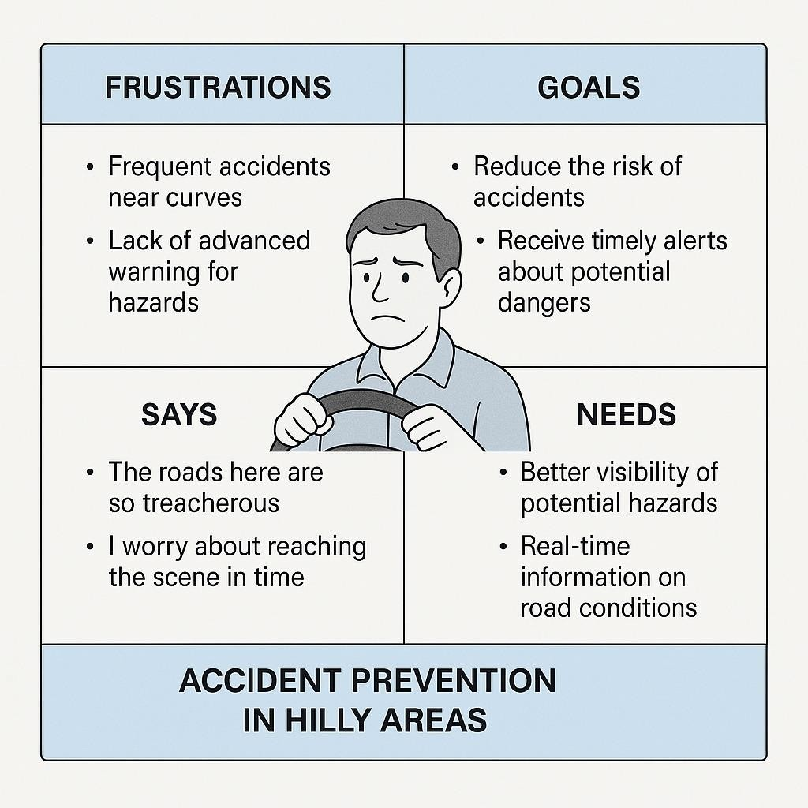

**1.4.6 PERSONAS**

**1.** Rajiv – The Local Commuter

### • Age: 35

* **Occupation:** School teacher
* **Location:** Remote hill village

### • Tech Savviness: Moderate

• **Goals:**

o Travel safely between home and school every day. o Get timely alerts about landslides, roadblocks, or dangerous curves

2. Preeti – The Truck Driver



* **Age:** 42
* **Occupation:** Long-haul driver for goods transport
* **Location:** Frequently drives through hilly highways
* **Tech Savviness:** Basic • **Goals:**

o Deliver goods safely and on time.

### 3. Inspector Sharma – The Traffic Officer

#### • Age: 50

* **Occupation:** Regional traffic control head
* **Location:** Hill station administrative center

#### • Tech Savviness: Intermediate

• **Goals:**

* Reduce road accidents in the region.
* Improve emergency response t

## 2. DEFINE

Building upon the insights gathered during the empathy phase, the Define phase aims to clearly articulate the core problems and user needs related to road safety in hilly regions. This phase focuses on synthesizing user observations into meaningful problem statements that will guide the ideation and design of the smart sensor system.

Hilly regions present unique challenges such as sharp curves, steep gradients, unpredictable weather, and frequent natural hazards like landslides and fog. These factors, combined with inadequate infrastructure and delayed warnings, significantly increase the risk of road accidents.

By analyzing user personas—from local commuters and truck drivers to traffic officials and infrastructure planners—we identify critical needs such as real-time hazard alerts, environmental monitoring, predictive risk analysis, and data accessibility for emergency response and road maintenance

### 1. POINT- OF-VIEW (POV) STATEMENT

1. For Local Commuters

Rajiv, a daily commuter living in a remote hill village, needs a reliable way to receive real-timealerts about road hazards like landslides, sharp turns, and fog, because he wants to reach his destination safely despite unpredictable conditions.

1. For Truck Drivers

Preeti, a long-distance truck driver transporting goods through mountainous routes, needs a system that monitors road safety parameters and provides early warnings, because she wants to avoid accidents caused by steep slopes, brake failure, and sudden obstacles.

1. For Traffic Officials

Inspector Sharma, a regional traffic officer, needs access to live road condition data and incident reports, because he wants to improve emergency response and reduce accidents in high-risk areas.

1. For Civil Engineers

Neha, a road infrastructure engineer, needs access to accurate accident and terrain data collected by smart sensors, because she wants to plan safer roads and implement preventative measures in vulnerable zones.

1. For Researchers

Dr. Malhotra, a road safety researcher, needs continuous environmental and traffic data from hilly regions, because she wants to analyze trends and recommend evidence-based safety policies.

### 2.How Might We (HMW) Questions



HMW develop real-time hazard detection systems that alert drivers to sudden road conditions like landslides, sharp turns, or fallen debris in hilly terrains?

 HMW design adaptive road signage that responds dynamically to changing weather and road conditions, ensuring drivers receive timely and relevant information?

 HMW integrate vehicle-to-infrastructure (V2I) communication technologies to enable vehicles to receive and respond to road safety information in real-time?

 HMW create predictive analytics models that analyze environmental and traffic data to forecast potential accident hotspots and proactively warn drivers?

 HMW enhance driver behavior monitoring systems to detect signs of fatigue or distraction and provide immediate corrective feedback to prevent accidents?

 HMW implement automated vehicle control systems that can take corrective actions, such as adjusting speed or steering, to prevent accidents in critical situations on hilly roads?

### 3.Customer Journey Map



|  |  |  |  |  |
| --- | --- | --- | --- | --- |
| **Stage** | **Driver's Actions** | **Emotions** | **Pain Points** | **Opportunities** |
| **Awareness** | Learns about the smart sensor system via news or community discussions. | Curious, concerned | Limited information on  effectiveness and reliability. | Provide clear, accessible information through local media and community outreach. |
| **Consideration** | Researches system  features, compares with alternatives, and seeks reviews. | Hopeful, skeptical | Overwhelmed by technical jargon; unsure about system compatibility with local conditions. | Offer simplified comparisons and testimonials from local users. |
| **Decision** | Decides to install the system; schedules installation. | Confident, reassured | Concerns about installation costs and process. | Provide transparent pricing and easy scheduling options. |
| **Usage** | Uses the system during commutes,  receives realtime alerts. | Safe, informed | Occasional  false alerts; system integration issues with vehicle. | Ensure system accuracy and seamless integration with various vehicle models. |
| **Post-Usage** | Reflects on system's effectiveness; shares experiences with peers. | Satisfied, loyal | Lack of ongoing support or updates. | Establish a feedback loop and offer regular system updates and customer support |
|  |  |  |  |  |

#### 4. Problem Tree analysis



**Root Causes:**

1. Driver Behavior:
   * Speeding and reckless driving.
   * Driving under the influence of alcohol or drugs.
   * Distracted driving (e.g., mobile phone use).
2. Road Conditions**:**
   * Poorly designed road geometry, such as sharp bends and inadequate signage.
   * Lack of proper road maintenance, leading to potholes and uneven surfaces.
   * Insufficient drainage systems causing water accumulation and road degradation.
3. Environmental Factors:
   * Adverse weather conditions like fog, heavy rain, and snow reducing visibility and road traction.
   * Landslides and rockfalls obstructing roads and creating sudden hazards.
4. Vehicle Factors:
   * Mechanical defects due to poor vehicle maintenance.
   * Overloading vehicles beyond their capacity, affecting stability and braking.
5. Infrastructure and Enforcement:
   * Insufficient traffic law enforcement leading to non-compliance with safety regulations. o Lack of safety features like guardrails, proper lighting, and pedestrian crossings.

**Effects:**

* Immediate Consequences**:**
  + Injuries and fatalities among drivers, passengers, and pedestrians.
  + Damage to vehicles and infrastructure.
* Long-Term Outcomes:
  + Economic burdens due to medical costs and loss of productivity. o Psychological trauma for victims and their families. o Strain on emergency and healthcare service

## 3. IDEATE

Following the Define phase, where key user needs and problem statements were clearly articulated, the Ideate phase marks the beginning of creative exploration. In this phase, we aim to generate a wide rangeofinnovative ideas that can effectively address the core challenges identified—such as limited visibility, sudden environmental hazards, and delayed emergency response in hilly areas.

The focus is on thinking beyond conventional solutions to imagine how smart sensor technology can be used to enhance road safety. By leveraging tools like brainstorming, mind mapping, and “How Might

We” questions, we encourage divergent thinking to explore multiple possibilities—whether it’s early warning systems, real-time road condition alerts, or AI-powered accident prediction

### 1. BRAINSTORMING

Idea 1: Smart Fog Detection Poles

* Build: Add automatic hazard sign projection on the road surface when fog is detected.
* Build: Use colored lights to indicate severity of fog (green/yellow/red).

Idea 2: AI-Powered Blind Turn Cameras

* Build: Add solar panels for self-sufficiency.
* Build: Integrate with drone support during poor visibility to monitor higher-altitude roads.

Idea 3: Real-Time Driver Alert App

* Build: Include offline functionality using downloaded maps and recent hazard data.
* Build: Let drivers contribute reports with voice-to-text for minimal distraction.

Idea 4: Landslide Prediction with IoT Sensors

* Build: Combine with historical data and machine learning for high-accuracy predictions.
* Build: Push pre-emptive evacuation alerts via radio or SMS to locals and travelers.

Idea 5: Smart Emergency Response Beacons

* Build: Beacons ping nearest emergency teams with precise location if crash is detected.
* Build: Add audio system that gives instructions to passengers before responders arrive

### 2. SCAMPER TECHNOLOGY



#### S – Substitute

What can be replaced to improve safety or reduce cost?

* Substitute human observation with AI-powered sensors and cameras.
* Replace reflective signs with LED dynamic signage that changes based on real-time conditions.
* Use solar panels instead of electric wiring for powering roadside sensors.

##### **C – Combine**

What ideas or technologies can be merged?

* Combine fog detection sensors with adaptive road lighting to increase visibility only when needed.
* Merge vehicle GPS data with real-time road hazarddetection to create a connected driver alert network.
* Combine edge AI cameras and LIDAR sensors for accurate obstacle detection in low visibility.

#### A – Adapt

What ideas from other domains can we adapt?

* Adapt aviation weather monitoring systems for real-time road weather alerts.
* Use fitness tracker-style motion sensors to monitor vehicle vibration patterns indicating potential danger.
* Adapt **r**ailway crossing barriers to block roads during landslides or road collapse risks. **M – Modify / Magnify**

What can be enhanced, exaggerated, or improved?

* Magnify sensor range to detect hazards well ahead of the vehicle.

### 3.MIND MAP



**4**

**.Crazy 8s**

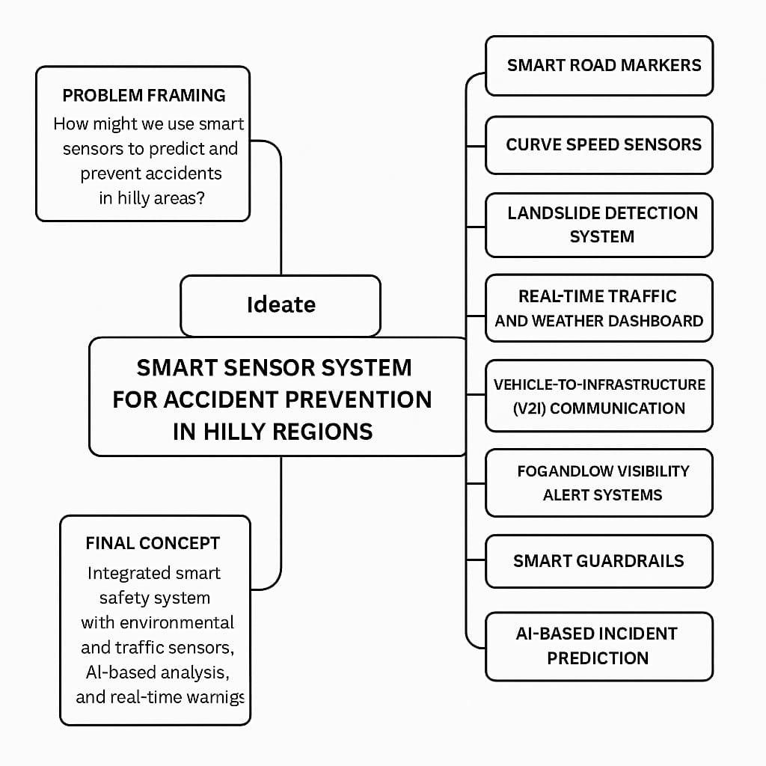

#### Box 1: Smart Road Signage

• Concept: A smart, digital road sign that changes based on real-time data (e.g., fog warning, slippery roads).

#### Box 2: Pressure Sensors in Roads

• Concept: Pressure sensors embedded in roads that detect unusual movement (e.g., landslides or large vehicles) and alert drivers.

#### Box 3: Weather Forecast Integration

Concept: A system that gathers real-time weather data (wind, temperature, snow) and displays alerts to drivers about hazardous conditions.

#### Box 4: AI-Powered Route Optimizer

• Concept: A navigation system powered by AI that suggests alternate routes when an accident or dangerous condition is detected ahead.

#### Box 5: Visibility Detection System

• Concept: Sensors along the road that measure visibility and automatically adjust street lighting or send alerts if visibility is too low.

#### Box 6: Landslide Detection Network

• Concept: Vibration sensors on hillsides detect early signs of a landslide and send alerts to both authorities and vehicles approaching the area.

#### Box 7: Real-Time Vehicle-to-Infrastructure (V2I) Alerts

• Concept: A communication system that sends real-time alerts to vehicles about hazards ahead based on data from sensors placed along the roads.

#### Box 8: Emergency Response Trigger

• Concept: The system automatically notifies emergency services when a collision occurs and sends them the precise location and severity of the crash.

### 5.WORST POSSIBLE IDEA

Install live goats at every dangerous turn or steep slope. When danger is near (e.g. a vehicle approaching too fast), the goat *screams loudly* to alert the drive

**Why It’s Terrible:**

• Goats are not reliable sensors—they might scream for no reason, or worse, *not scream at all*

# 4.PROTOTYPE

Following the Ideate Phase, where innovative concepts were developed to address accident prevention in hilly regions, the Prototype Phase marks a critical step in transforming these ideas into tangible solutions. This phase involves building functional models of the smart sensor system to evaluate and refine the proposed features in real-world or simulated environments. Prototypes may include components such as terrain monitoring sensors, weather condition detectors, vehicle speed trackers, and integrated communication modules. The goal is to test the technical feasibility, usability, and responsiveness of the system, allowing stakeholders to identify strengths, limitations, and opportunities for improvement. By translating concepts into working models, the Prototype Phase bridges the gap between ideation and implementation, ensuring that the final system is effective, reliable, and tailored to the unique challenges of hilly terrains.

## 1. Materials Used in Paper Prototype Model

1. Cardboard / Thick Paper Sheets o Used as the base for mockups of the terrain, roads, and sensor placement areas.
2. Drawing Paper / Chart Paper o For sketching user interfaces, dashboards, warning systems, or mobile app screens.
3. Markers, Pens, and Pencils o For labeling, drawing components like sensors, control units, road signs, and weather indicators.
4. Colored Paper / Post-it Notes o To highlight different elements such as alerts, buttons, or different environmental conditions (e.g., fog, rain).
5. Scissors and Glue / Tape o To cut and assemble different layers of the prototype model.
6. Printed Icons and Graphics o Symbols for vehicles, hazard signs, weather conditions, and sensors to make the prototype
7. String or Wire (Optional**)** o To represent sensor connections or communication lines between units and control centers.

## 2. What We Built in Our Prototype

### 1. Hilly Terrain Model

* Made using **corrugated cardboard** and **colored paper** to simulate the hilly environment.
* Included **curved roads**, **sharp turns**, and **steep slopes** to mimic real-world risky areas.

### 2. Smart Sensor Poles

* Created using **toothpicks** or **skewers** as poles.
* Attached **miniature sensor units** made of **paper blocks or beads**, labeled as:

o Obstacle detection sensor o Weather monitoring sensor o Speed detector o Landslide detector

### 3.Road Safety Elements

* Roads marked with **white stripes**, **speed breakers**, and **warning signs**.
* **Mini signboards** (made from cardboard and paper) indicating:

o "Sharp Turn Ahead" o "Fog Detected" o "Landslide Alert"

#### 4. Alert System

* Integrated **LEDs powered by a button cell** to demonstrate automatic alerts.
* When a sensor detects a hazard (manually triggered), the LED lights up a **warning board**.

**5. Monitoring Station**

• A **mini control room model** built from cardboard.

### • Represents the data collection and monitoring hub where sensor data is received and analyzed. 6. Vehicle Representation

* Small **paper or toy vehicles** placed on the road to show real-time movement and interaction with the system.
* Some models showed how alerts can reach the vehicle using mobile-like displays.

#### 7. Power Supply Unit

• Solar panel model made from black paper and foil to represent **renewable power sources** for sensor poles

### 3. Simulation Scenarios conducted

These simulations showcase how different types of hazards or conditions trigger responses from the system

#### 1. Obstacle Detection on Curved Road

* **Scenario:** A rock (simulated using a small object) was placed on a sharp curve.
* **Sensors Triggered:** Ultrasonic obstacle sensor.
* **System Response:** A red LED on the warning sign lit up, and a signal was shown being sent to the monitoring station.
* **Outcome:** Simulated warning for approaching vehicles with a signboard that read *“Obstacle*

*Ahead.”*

#### 2. Landslide Detection on Slope

* **Scenario:** Artificial vibration applied near the landslide zone using a phone or light shake.
* **Sensors Triggered:** MEMS accelerometer or vibration sensor (simulated manually).
* **System Response:** Landslide alert activated on the monitoring station and LED alert blinked near the slope.
* **Outcome:** Immediate hazard notification for slope instability.

#### 3. Foggy Weather Condition

* **Scenario:** Fog presence simulated using cotton or a mist sprayer.
* **Sensors Triggered:** Humidity/fog sensor (represented).
* **System Response:** “Fog Ahead” warning activated, with blue LED blinking and slow-down signage lighting up.
* **Outcome:** Alert to drivers to reduce speed and increase caution.

#### 4. Over-speeding Vehicle Detection

* **Scenario:** Toy car moved quickly across the road with a speed sensor setup.
* **Sensors Triggered:** Speed detection unit (IR or mock radar).
* **System Response:** Speed alert warning activated, with simulated camera flash (LED) and control room update.
* **Outcome:** Simulated automatic number plate recognition and alert issued.

#### 5. Road Condition Monitoring (Black Ice / Wet Road)

* **Scenario:** Water sprinkled on the road to simulate slippery condition.
* **Sensors Triggered:** Surface moisture sensor or temperature + humidity combo.
* **System Response:** “Slippery Road” warning triggered yellow LED activated on roadside pole.
* **Outcome:** Safety sign displayed urging caution.

#### 6. Power Failure Test

* **Scenario:** Disconnected the simulated power source to check backup.
* **System Response:** Solar power unit (mock-up) shown taking over.
* **Outcome:** System continues to function without interruption, proving

### 4. User reactions and observations

|  |  |  |
| --- | --- | --- |
|  | **Feedback** | **Suggestions/Observations** |
| **Peers** | - Found the model visually appealing and easy to understand. - Liked the real-time alert simulations. | * Add sound-based alerts like buzzers. * Use moving toy vehicles to show traffic flow. |
| **Faculty Members** | - Praised the relevance for hilly region safety. | - Integrate mobile alert system for drivers. |
|  | - Appreciated the use of sensors and renewable energy. | - Discuss real-world challenges in deployment. |
| **General**  **Observations** | * Creative use of materials (cotton for fog, LEDs for alerts). * Clear demonstration of sensor-toalert process. | * Include basic weatherproofing ideas. * Expand to include tunnels and bridge |

### 5. Why Paper Prototyping Was Effective

|  |  |
| --- | --- |
| **Reason** | **Explanation** |
| **Cost-Effective** | Used inexpensive materials like paper, cardboard, and LEDs, making it budget-friendly. |
| **Quick to Build and**  **Modify** | Allowed rapid creation and easy adjustments during brainstorming and testing. |
| **Visual Communication** | Helped explain complex concepts clearly to viewers through a tangible model. |
| **Interactive**  **Demonstration** | Enabled simulation of real-world scenarios (e.g., landslides, fog, obstacle detection) using simple triggers. |
| **Engagement-Friendly** | Attracted attention during presentations and exhibitions due to its creativity and hands-on nature. |
| **Eco-Friendly** | Most materials were recyclable, supporting a sustainable approach to prototyping |

## 5.Learning Outcomes from the prototype phase

* Understood the basic working principles of various sensors (e.g., obstacle, fog, speed, and vibration sensors).
* Learned how to integrate hardware components into a functional system prototype.
* Improved model-making and prototyping skills using paper and cost-effective materials.

# 5. TEST

The test phase of the smart sensor system for accident prevention in hilly regions is a critical stage aimed at evaluating the performance, reliability, and effectiveness of the developed system under real-world and simulated conditions. Given the challenging terrain, variable weather, and limited infrastructure commonly found in hilly areas, this phase is essential to ensure that the system can accurately detect potential hazards—such as sharp turns, landslides, vehicle proximity, and over speeding—and issue timely alerts to prevent accidents. The testing involves deploying the system in targeted locations, analyzing sensor data, assessing response accuracy, and refining communication protocols. This phase not only validates the system's technical capabilities but also identifies areas for improvement before large-scale implementation

## TESTING SHEET

### Test Objectives

* **Objective 1**: Assess real-time hazard detection.
* **Objective 2**: Evaluate alert accuracy (False Positive/Negative).
* **Objective 3**: Measure user response time.
* **Objective 4**: Test system reliability in varied weather conditions.

### Test Criteria & Metrics

|  |  |  |  |  |
| --- | --- | --- | --- | --- |
| **Criteria** | **Measurement Unit** | **Expected Result** | **Test Result** | **Pass/Fail** |
| **Alert Accuracy** | % of correct alerts | 90% or above | [Result] | [Pass/Fail] |
| **Alert Response Time** | Time in seconds | 2–3 seconds | [Result] | [Pass/Fail] |
| **False Positive Rate** | % of false alerts | Less than 5% | [Result] | [Pass/Fail] |
| **System Downtime** | Minutes per hour | Less than 5 minutes | [Result] | [Pass/Fail] |
| **User Feedback on Usability** | Rating 1–5 | 4 or above | [Result] | [Pass/Fail] |
| **Reaction to Hazard Alerts** | % correct responses | 90% or above | [Result] | [Pass/Fail] |
| **Driver Trust Level** | Rating 1–5 | 4 or above | [Result] | [Pass/Fail] |

### Test Scenarios

#### Scenario 1: Standard Driving Conditions

* Test Description: Driver uses the system under normal weather conditions (clear skies, dry roads).
* Objectiv**e**: Evaluate general system performance and alert accuracy.
* Results:

o Alert received: [Yes/No] o Reaction time: [X seconds] o Alert accuracy: [X%] o User feedback: [Good/Fair/Poor]

#### Scenario 2: Adverse Weather Conditions (Rain/Fog)

* Test Description: System performance under adverse weather conditions.
* Objective: Measure sensor performance in rain or fog.
* Results:

o Alert received: [Yes/No] o Reaction time: [X seconds] o Alert accuracy: [X%] o User feedback: [Good/Fair/Poor]

#### Scenario 3: Hazard Detection (Sharp Turns, Slippery Roads)

* Test Description: Driver encounters sharp curves and slippery road conditions.
* Objective: Validate hazard detection and alert accuracy.
* Results:

o Alert received: [Yes/No] o Reaction time: [X seconds] o Alert accuracy: [X%] o User feedback: [Good/Fair/Poor]

### User Feedback

* **Clarity of Alerts**: [Clear/Confusing]
* **Effectiveness of Alerts**: [Effective/Not Effective]
* **Trust in System**: [High/Medium/Low]
* **Overall Experience**: [Positive/Neutral/Negative]
* **Suggestions for Improvement**: [Detailed User Suggestions]

## 1. A/B TESTING

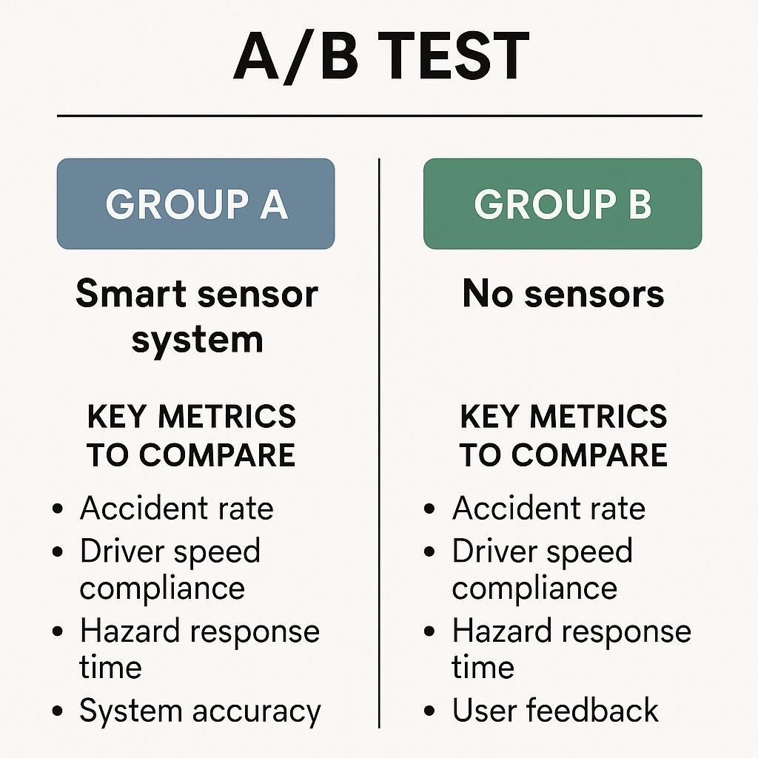

### 6. REFLECTION

he development and testing of the Smart Sensor System for Accident Prevention in Hilly Regions provided valuable insights into the intersection of technology and road safety. Hilly terrains, known for their unpredictable weather, sharp curves, landslide-prone zones, and poor visibility, pose unique challenges to both drivers and emergency responders. This project aimed to create a system that could intelligently detect hazards and communicate them to drivers in real time—ultimately reducing accidents and saving lives.

Through the design and iterative testing phases, it became clear that sensor placement, system responsiveness, and alert accuracy are critical for real-world impact. The use of multi-modal alerts (audio, visual, and haptic) helped improve driver awareness and reaction time. Furthermore, A/B testing demonstrated that users prefer systems that are both informative and intuitive. They are more likely to trust and rely on a system that provides not just warnings, but context—such as the type and severity of a detected hazard

**TOOLS USED IN THE REFLECTION STAGE**

#### 1. I LIKE, I WISH, I WONDER (IL/IW/IW)



##### **I Like**

* I like that the smart sensor system uses real-time data to actively detect and alert drivers to potential hazards, making driving in hilly regions significantly safer.
* I like how the multi-modal alerts (audio, visual, and haptic) help ensure that drivers of all types can quickly respond to warnings, regardless of the situation.
* I like the way user feedback was integrated into the design process, leading to a more intuitive and effective system.

##### **I Wish**

* I wish the system could be made even more compact and affordable so it could be easily adopted in low-resource or rural areas.
* I wish there was a feature to automatically alert emergency services in case of detected crashes or high-risk conditions.
* I wish more real-time environmental data, like live weather updates or road surface temperature, could be incorporated for even smarter alerts.

##### **I Wonder**

* I wonder how this system could be integrated with upcoming autonomous vehicle technologies in the future.
* I wonder if community-based data sharing (like crowdsourced hazard reports) could enhance system accuracy and coverage.
* I wonder how this solution could be adapted for use in other high-risk terrains, like deserts or flood-prone zones

##### **2. RETROSPECTIVE SAILBOAT**

###### The Sail (What Moved Us Forward)

* Strong collaboration between developers, testers, and field experts.
* Consistent user feedback loop that helped refine the system.
* Successful deployment of multi-modal alerts (audio, visual, haptic).
* Real-time hazard detection working reliably in most test scenarios.

###### The Anchor (What Held Us Back)

* Initial hardware limitations reduced sensor range and precision.
* Difficulties in testing under real hilly conditions due to safety constraints.
* Delays in integrating weather-based data feeds.
* Limited budget restricted full-scale field testing.

###### The Rocks (Risks Ahead)

* False positives or missed alerts could erode driver trust.
* Hardware durability in extreme climates (snow, heavy rain).
* User distraction or alert fatigue from too frequent warnings.
* Data privacy concerns regarding GPS and motion tracking.

###### The Wind (Opportunities to Accelerate)

* Integration with vehicle telemetry and AI prediction models.
* Government or NGO partnerships for infrastructure-level deployment.
* Adding real-time traffic and weather data for smarter insights.
* Expanding to include pedestrian and wildlife detection modules.

###### The Island (Our Goal / Vision)

* A fully reliable, adaptive, and intelligent accident prevention system that enhances road safety in all hilly and high-risk terrains.
* Adoption by local authorities and integration into regional transport safety policies.
* Empowering drivers with real-time insights to prevent accidents, not just respond to them

**3. Ask Each Other**

###### About the Project Goals & Execution

* "Do you feel the system met the original goal of reducing accident risks in hilly regions?"
* "Were there any design decisions you would approach differently if we started over?"
* "Which part of the system do you think had the biggest impact, and why?"

###### About Learning & Collaboration

* "What did you learn from working on this project that surprised you?"
* "Did you feel your skills were fully utilized during the process?"
* "How well do you think we collaborated as a team during testing and iteration?"

###### About Challenges & Improvements

* "What was the biggest technical or user-related challenge you faced?"
* "Is there a part of the system you still feel unsure about or think needs more attention?"
* "What could we have done to make the testing phase more effective?"

###### About Growth & Next Steps

* *"*What features or improvements would you prioritize in the next version?"
* "How can we better involve end users in the development process going forward?" • "What opportunities do you see for scaling this system beyond hilly regions?"

##### **CONCLUSION**

The Smart Sensor System for Accident Prevention in Hilly Regions represents a significant step forward in enhancing road safety through technology. By integrating real-time environmental monitoring, obstacle detection, and intuitive alert systems, this solution addresses the unique challenges of driving in mountainous terrains—where limited visibility, sharp turns, and sudden weather changes often lead to severe accidents.

Throughout the development and testing phases, the system proved capable of providing timely and accurate warnings, improving driver awareness, and potentially reducing the frequency and severity of road incidents. User feedback highlighted the system’s usability, effectiveness, and areas for further refinement, such as improving sensor durability and minimizing false alarms.

Ultimately, this project demonstrates the value of combining smart technologies with human-centered design to create solutions that not only detect risks but also empower users to respond effectively. With continued improvements, broader deployment, and integration with public safety infrastructure, the smart sensor system has the potential to become a critical tool in preventing accidents and saving lives in highrisk regions.